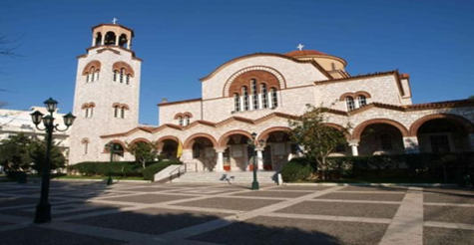
St. Trifon church
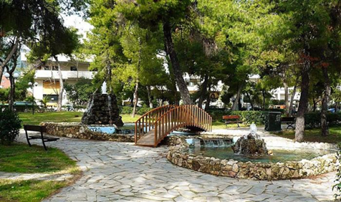
Schools in our town
We have many schools in our town.
- 9 kindergartens
- 7 primary schools
- 3 junior high schools
- 2 senior high schools
- 1 music school and
- 5 private schools

Well-known people from Pallini
.
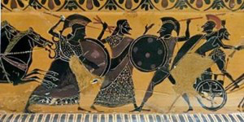
Ameinias was born in Pallini (in about 520-510 B.C).
He was the first captain to hit and sink a ship of the Persian fleet . He also sank the ship of the admiral of the Persian fleet and saved Themistokles .
He was awarded with a medal for his bravery.
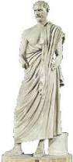
Demosthenes was born in 384 B.C and died in 322 B.C .
He was a great orator in ancient times . It is said he was born and lived in Pallini. He fought as a normal warrior in Heronia and got captured from the Macedonian king Philippos II. His speeches were against Alexander the Great and his attacking war. In 322 B.C. he killed himself being chased, in order not to get captured for his political opinion.

Dimitris Nanopoulos is a scientist born in Pallini in 1948.
He studied physics in the University of Athens and he also graduated from Sussex University. He has worked in C.E.R.N in Geneva, in Harvard University and as a professor in A&M University of Texas.

2nd High School Pallini

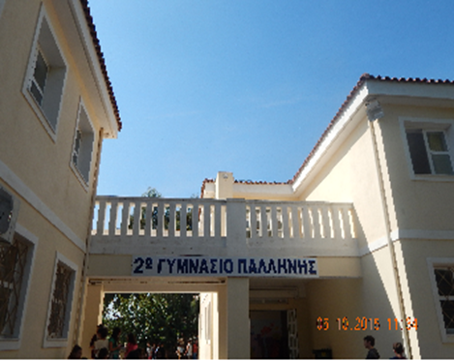
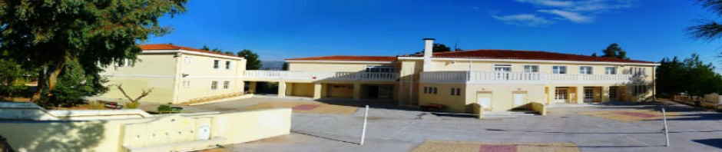

Coordinates: 38°0′N 23°53′E
Country | Greece
Administrative region | Attica
Regional unit | East Attica
Area
Municipality | 29.43 km²(11.36 sq mi)
Municipal unit | 18.93 km²(7.31 sq mi)
Elevation | 150 m (490 ft)
Population (2011) 54.415
Municipality | 29.43 km²(11.36 sq mi)
Municipality density | 1,800/km²(4,800/sq mi)
Municipal unit | 22,344
Municipal unit density | 1,200/km²(3,100/sq mi)
Time zone | EET (UTC+2)
Summer(DST) | EEST (UTC+3)
Postal code | 15351
My town- Pallini

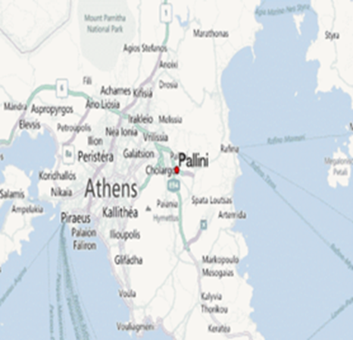
Pallini (Greek: Παλλήνη) is a suburban town and a municipality in East Attica, Greece. The seat of the municipality is the town Gerakas. It is the seat of administration of the East Attica regional unit. Pallini is situated in the eastern part of the Athens conurbation, at about 150 m elevation. It lies in a plain between the mountains Penteliko and Hymettus It is 2 kms east of Gerakas and 14 kms east of Athens city center. Its built-up area is continuous with those of the neighbouring suburbs Gerakas and Anthousa. Pallini station, west of the town centre, is served by commuter trains and Athens metro. Greek National Road 54 (Athens - Rafina) passes through Pallini. The municipal unit of Pallini includes the subdivision of Leontari.
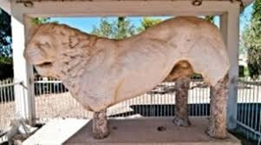
Leontario is an urban area of Pallini town. There is a strong possibility, that the famous ancient orator Demosthenes lived in this area. At 1986, during excavations ancient monuments were discovered. The main discovery The Marble Lion is standing at the backyard of St. Nikolas church. Many people visit this tourist attraction.
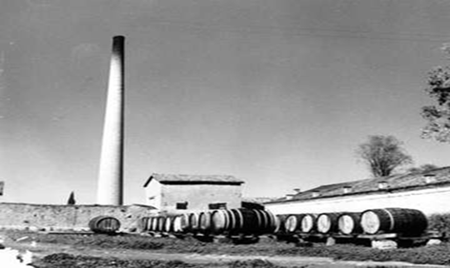
Kampas winery was the first industrial wine factory in Greece, since 1875. The founder Andreas P. Kampas bought 5000 m² of land where he cultivated the best grapes in the country. The winery’s operation was terminated at late 90’s.

