Guide to Úbeda
Let yourself be enchanted by a city full of history, where time stops and the legacy of the stone gives it the "Heritage of Humanity" emblem. Churches, palaces and museums, in an urban environment surrounded by landscapes of olive trees, define this tourist destination.
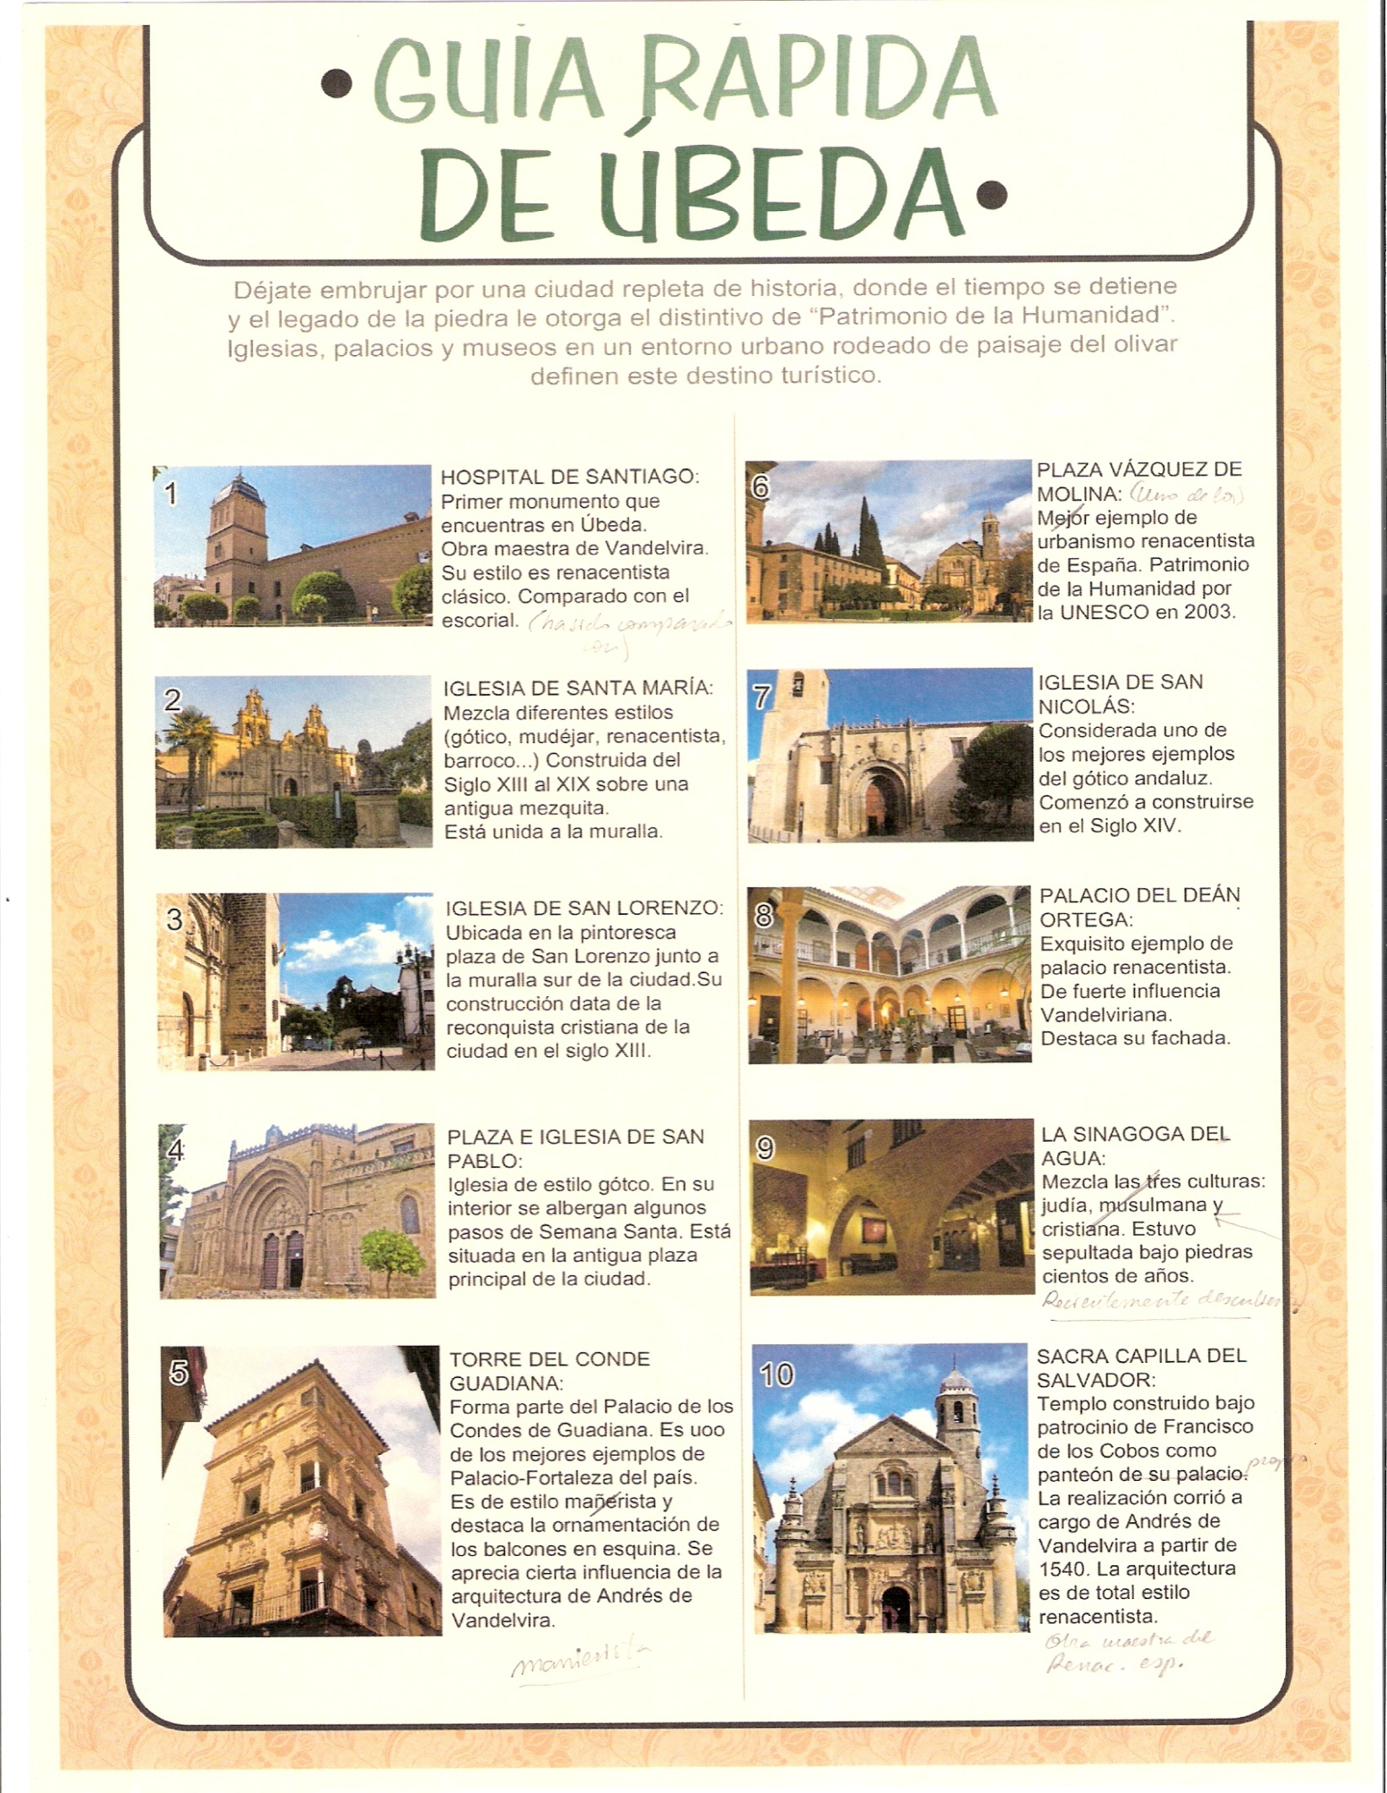
Santiago Hospital is considered the “Andalusian Escorial” and it is probably Vandelvira’s most accomplished work. Its sober façade provides a marked contrast to its surprising interior. Its chapel is particularly worth a visit!

Basilica of Santa María de los Reales Alcázares is one of the best example of how the passing of time and the architectural evolution could change its aspect. We can find on it some rests of a Roman temple devoted to the goddess Diana and a Moorish mosque. Built between the 13th and 19th, it's a mix of different styles (Gothic, Mudejar, Renaissance, Baroque ...).

Church of St Lorenzo, dated from the end of the 13th century after the Christian conquest and perhaps taking advantage of the factory of a primitive Muslim mosque, was totally rebuilt in the 16th. The temple rests directly on the south wall of the city, being located next to two old entrances of the town: Granada Gateway and the Gateway of St Lorenzo.

Church of St Pablo is placed near Vázquez de Molina Square. It was founded in the 12th century on the previous mosque. The main façade -Isabelian styled- is dated from 1511. The inner Late-Gothic styled temple appears surrounded by excellent and Gothic and Renaissance chapels

The Palace of the Counts of Guadiana was built by Lope de la Cueva y Guzman. The building dates from the last decade of the 16th century and the tower was built between 1611 and 1615. The style of the building is Plateresque. The most notable feature of the palace is its tower, considered one of the most beautiful towers in Spain. It has corner balconies with white marble columns and there are galleries on the third floor.

Vázquez de Molina Square is one of the best examples of Renaissance architecture in Spain. The Spanish Renaissance architectural value of this square was one of the motives for UNESCO's decision to declare the town a World Heritage site in July 2003.

St Nicholas's Church is perhaps the best example of the Andalusian Gothic. The Mannerist-styled doorway is by Andrés de Vandelvira.

The Palace of the Dean Ortega is other of the most emblematic buildings in Vázquez de Molina Square. Besides the possibility of visiting it, you will also eat and stay in it because it is the National Tourism Parador (a state-run hotel) since 1930.
The design of the building was made by the Renaissance architects Andrés de Vandelvira and Luis de la Vega.
Like other palaces that you can see in Úbeda, it is characterized by a central square courtyard which distributes all the building. The two floors rise with an arch gallery held up by marble columns.

The Synagogue of Water was discovered by chance during some property jobs. Mixture of the three cultures: Jewish, Muslim and Christian. Visiting the Synagogue of the Water is knowing first-hand how the Jewish communities settled in Úbeda used to live.

Sacred (Holy) Chapel of the Savior, designed by the architect Diego de Siloé, is the most ambitious temple of the private architecture of the 16th century in Úbeda. Vandelvira, who crafted the entire Sacristy, carried out its construction. The front façade, sculpted in stone by Esteban Jamete, is one of the most beautiful in Andalusia with an impressive relief of the Transfiguration of Jesus.
Francisco de los Cobos, secretary of Emperor Charles V, had this chapel built as his own pantheon.

